Lab1 Report

Rayan Katib

08-29-13

The first task in this lab is to create an account on the ScrumDo website. Here is a screen shot that shows the account created under my username: rfkfy6.

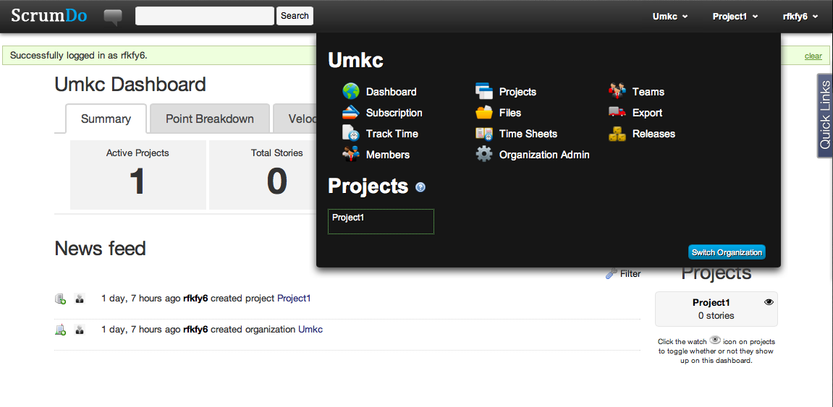

The second task is to create an account on GitHub.com.

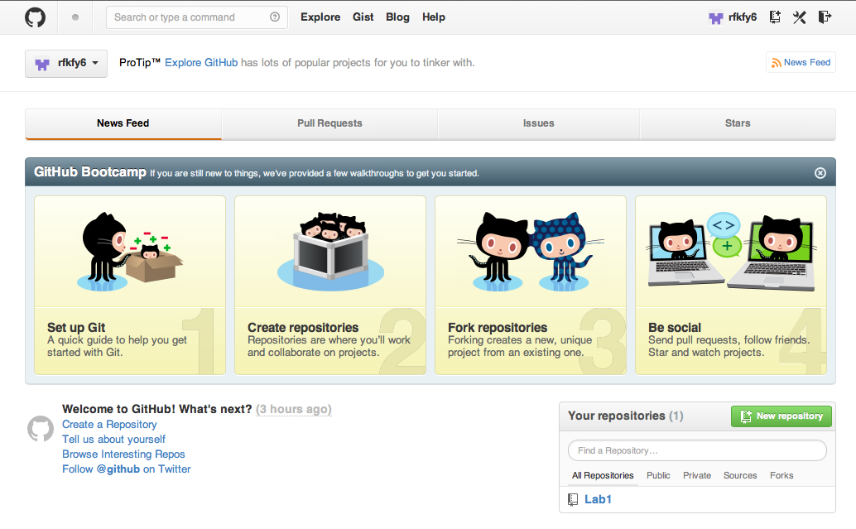

Finally the third task is about drawing a security home system design using UML. A class diagram, sequence diagram, and an architecture design are the three required diagrams. The first one is the class diagram that shows how each part of the system is connected with other parts. For example, the diagram shows how the system connects between the sensors and the control screen and then how it alarms the owner. The second diagram is the sequence diagram, which is about the action and responses that happen inside the system in case a sensor is triggered. The files of these designs are uploaded to the GitHub account.